*TECNO mobile*

*TECNO POP 5 LITE*

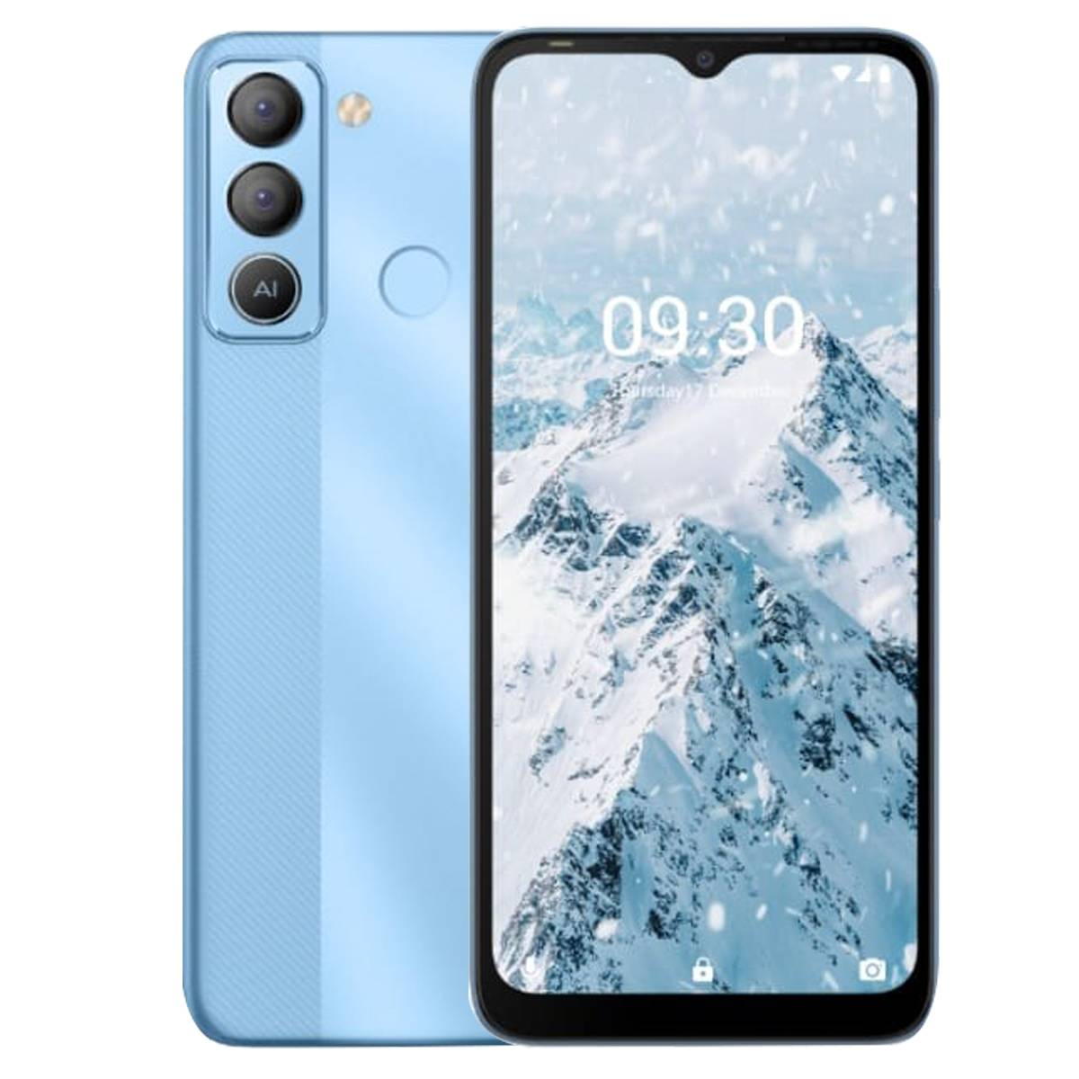

**Tecno Pop 5** LTE ; Display. Technology, IPS LCD Capacitive Touchscreen, 16M Colors, Multitouch. Size, 6.52 Inches. Resolution, 720 x 1560 Pixels (~264 PPI) …

**PRICE /24,999.00 PRK**